Chapter 11 – Lesson 4 – Chemical Properties and Changes
Chemical Properties
A chemical property is a characteristic of matter that can be observed as it changes to a different type of matter.
Ex: Paper burning is a chemical change. You can observe the paper and watch it burn and turn into a different substance. Burning is a chemical property.

Another chemical property is rusting.
Comparing Properties
All matter can be described using BOTH physical properties and chemical properties.
EX: A wood log is solid, round in shape, heavy, and rough (physical properties). The wood also has the ability to burn and decompose (these are chemical properties).
Chemical Changes
A chemical change is a change in matter in which the substances that make up the matter change into other substances with new physical and chemical properties. (A new substance is formed)
(Show iron rusting at molecular level as example)
Signs of Chemical Change
How do you know a chemical change has occurred – there are different signs or clues to look for?
- Formation of bubbles (gas produced)
- Color Changes
- Energy Changes (Thermal energy released, Light energy released)
- An odor
- Precipitate forms
It is important to remember that these sings do not always indicate a chemical change – the only proof a chemical change has occurred is the formation of a new substance.

Explaining Chemical Reactions
When atoms bond together in new combinations, new substances are formed. This process is called a reaction.
Chemical changes are often called chemical reactions
Using Chemical Formulas
A useful to understand what happens during a chemical reaction is to write an equation.
A chemical equation shows the chemical formula for each substance.
The formulas to left of the arrow indicate the reactants and the formulas to the right of the arrow represent the products. (products are the new substance(s) that are formed)
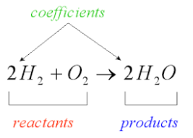
Balancing Chemical Equations
Look at the equation:
Fe + S FeS
Notice there is one iron atom on the reactant side (left) and one iron atom on the product side (right). This is also true for sulfur.

Remember that mass is conserved – therefore in a chemical equation the number of atoms of each element before the reaction must equal the number after the reaction. This is called a balanced chemical equation.

How to write a balanced Chemical Equation.
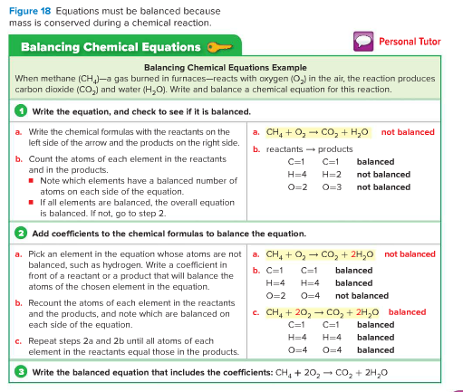

When balancing a chemical equation you cannot change the chemical formula of any reactants or products, instead you can place coefficients in front of formulas.
(use Personal Tutor online for Balancing Chemical Equations)

The Rate of Chemical Reactions
Recall that the particles that make up matter are moving and colliding with each other. Different factors can make the particles move faster and collide harder and more frequently. These factors increase the rate (speed) of a chemical reaction.
